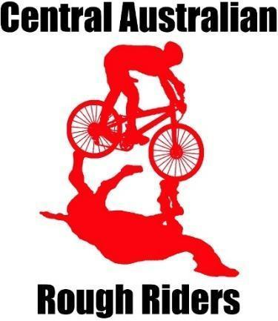

Alice Springs Mountain Bike club
Dusty Demons

Welcome to Dusty Demons 2024.

What and Who: Dusty Demons is the club’s junior mountain bike (MTB) program. It is an inclusive and fun MTB activity for 8 - 12 year olds who are competent using brakes and gears, and ready to ride single track.
Why: to have fun riding with other kids, improve MTB skills and ride awesome local single track.
When: 4.30pm - 5.45pm
- Term 2 every Monday from 15 April till 17 June except 6 May, May Day, and 10 June Kings Birthday
- Term 3 every Monday from 22 July till 16 September, except 5 August Picnic Day.
Where: Dirt Jumps at Francis Smith Park between Bourke St and Kurrajong Drive, East Side.
How: The groups are sorted according to skill level and led by a certified MTB instructor and usually assisted by a volunteering parent or two.
Sessions may include riding on MTB specific single track, workshopping obstacles, learning MTB skills, bike & gear check, and/or bike maintenance.
Cost: The program cost is $130. This includes Terms 2 & 3, a total of 16 sessions facilitated by a MTB instructor, skill improvement, learning the trails, increased confidence, an end-of-season BBQ, and tonnes of fun.
Membership
Membership is required. Membership options for your child/children include:
- an AusCycling Lifestyle monthly ($9.50) or 12-month membership (about $81).
- membership support of the club, Central Australian Rough Riders (CARR) is appreciated and free for juniors.
* Please note when you join your child to AusCycling you will be asked to join a club and charged $25 if you do not.

Expectations:
Bring a functioning bike, helmet, water bottle for hydration, and closed toe shoes.

How do I join?
Your child must get AusCycling membership first and then register for the program here. Please note you will need to use the same email for membership and program registration. There are 35 places and the program fills quickly so register your child now.

Sport Vouchers can be used towards the program cost. Email the sport voucher to georgelandy@gmail.com, a discount code will be issued, then sign up for the program.

Communication will be mainly through email.

Have a look at the club’s website at www.carralicespringsmtb.com to download the calendar and see what other awesome mountain bike opportunities are available.

Follow the club on Facebook.

Dusty Demons relies on volunteers for its success. You are encouraged to please help and contribute to the thriving Alice MTB community and increase your wellbeing at the same time (the research says so!). Speak to our wonderful instructors to find out how to get involved.

We look forward to riding with you and your amazing kids!

