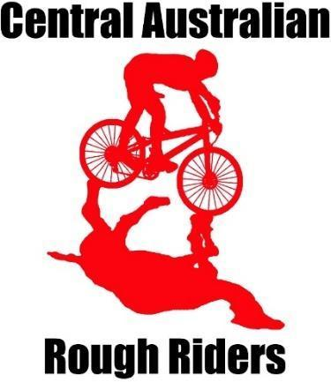

Alice Springs Mountain Bike club
Mini Dusty Demons

Welcome to Mini Dusty Demons 2024.

What and Who: Mini Dusty Demons is part of the club’s junior mountain bike (MTB) program. It is an inclusive and fun MTB activity for 3 to 7 year olds who are still developing skills in braking, balance, and changing gears.
Why: to have fun riding with other kids and improve bike handling skills.
When: 4.30pm - 5.30pm
- Term 2 every Monday from 15 April till 17 June except 6 May, May Day, and 10 June Kings Birthday
- Term 3 every Monday from 22 July till 16 September, except 5 August Picnic Day.
Where: Dirt Jumps at Francis Smith Park between Bourke St and Kurrajong Drive, East Side.
How: The children participate in a variety of activities that encourage fun, balance, practice and improvement of basic bike riding skills, for example, relays, games and little adventures.
Each session is facilitated by a volunteering MTB instructor parent or two.
Cost: The program cost for Mini Dusty Demons is $40.

Membership
AusCycling membership is required to participate in this program. Membership options for your child/children include:
- an AusCycling Lifestyle monthly ($9.50) or 12-month membership (about $81).
- membership support of the club, Central Australian Rough Riders (CARR) is appreciated and free for juniors.
* Please note when you join your child to AusCycling you will be asked to join a club and charged $25 if you do not.

Expectations:
Bring a functioning bike, helmet and water bottle for hydration.

How do I join?
Your child must get AusCycling membership first and then register for the program here. Please note you will need to use the same email for membership and program registration. There are 35 places and the program fills quickly so register your child now.

Sport Vouchers can be used towards the program cost. Email the sport voucher to georgelandy@gmail.com, a discount code will be issued, then sign up for the program.

Communication will be mainly through email.

Have a look at the club’s website at www.carralicespringsmtb.com to download the calendar and see what other awesome mountain bike opportunities are available.

Or you may want to follow on Facebook.

Mini Dusty Demons relies on volunteers for its success. You are welcome and encouraged to help and contribute to the thriving Alice MTB community and increase your wellbeing at the same time (the research says so!). Speak to our wonderful instructors to find out how to get involved.

We look forward to riding with your amazing kids!

